Supply Chain Key Factors  - Availability  - Cost  - Timeliness  - Quality  - Compliance  Basic Requirements  - Items/Parts  - Certifications  - Traceability  - Vendors  - Status  - Certifications  - Custom Details  Purchase Order Management  - Group and sum parts across Work Orders and Projects  - Manufacturing  - Repair  - Link parts data from PR to PO to IR to WO  - Easily select Vendor based on  - Cost  - Availability  - Quality  - Timeliness  - Compliance  Vendor Portal  - Vendor to Review RFQ and Open Purchase Orders:  - Enter and Update Price  - Enter and Update Delivery Date | In the fast-paced world of aviation, where precision and timeliness are paramount, Epiphany’s Supply Chain ConnectX is an essential tool for complex supply chain challenges such as the uncertainties of inflation, fluctuating customer demand, and the pervasive issue of labor shortages. This state-of-the-art management solution will propel your business into a new era of agile operations.  Supply Chain ConnectX embraces the five pillars of procurement:  - Availability  - Cost  - Timeliness  - Quality  - Compliance  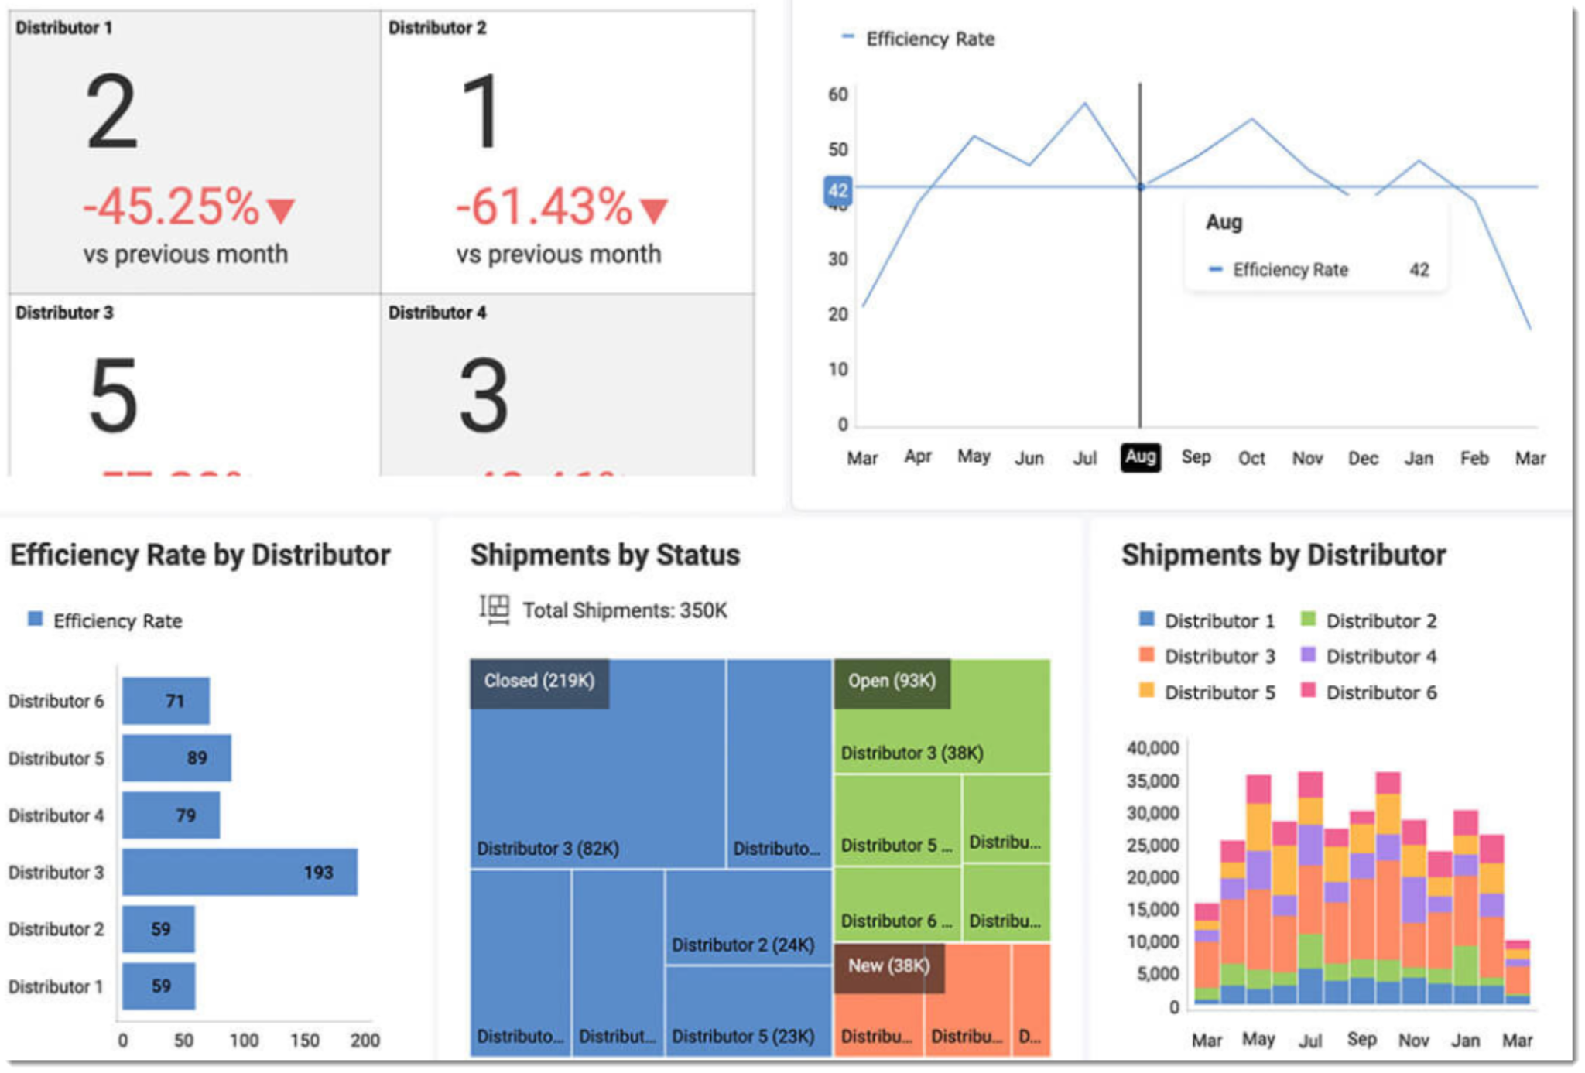  Developed 100% on the ConnectX platform which provides out-of-the-box data updates and data integration with multiple systems.

Business Benefits and Features
Supply Chain ConnectX
Real-time visibility across your business portfolio
Business Benefits | Features
Obtain a 360-degree view of Supply Chain needs for manufacturing and repair teams..  Supply Chain ConnectX allows you to:  - Pull data from customer pdf specifications into a readable table in ConnectX  - Track Items from Customer requests  - Manage Vendor Selection  - Cost  - Availability  - Quality  - Timeliness  - Compliance  - Manage Inventory and Purchasing with ease  - Assess Parts List  - Pull parts from multiple Purchase Requests to a single Purchase Order  - Pull and Push PDF Data from Document to Table  - Sort Specifications and Bill Of Materials into easy to read views  - Integration with financial software providing the ability to use Purchase Order data to create AP Bills | - Part Ordering Management  - Vendor Management  - Vendor Portal  - Integration with Financial System  - Supply Chain Management Dashboard  - Track related metrics and Key Performance Indicators (KPI’s)  - Real-time analytics  - Drill-down to detail for further analysis  - Comprehensive reporting capabilities  - Role-based access and security  - Built-in Business Intelligence  - Which Suppliers are the most reliable?  - How many days of inventory per Warehouse?  - Are we meeting demand?  - How close are material forecasts to actual results?  - What is the timeliness history per vendor per item?  - What is the quality rating per vendor per item?  - What is compliance per vendor per item?

