ConnectX Platform Capabilities  - System Integrations  - Quickbooks  - NetSuite  - Salesforce  - Edit Data in System before pushing data back to System of Origin  Basic Requirements  - Cloud Access  Modules  - Supply Chain ConnectX  - Items  - Vendor Portal  - Purchase Orders  - Quotes  - Manufacturing ConnectX  - MRO ConnectX | Tired of spending countless hours creating manual spreadsheets, running queries, making decisions, just to find that the information you need is outdated or can’t be found? Say “Goodbye” to the tedious and “Hello” to our ConnectX Platform for Data Requirements!  Our platform will empower you to drive your data into a single view from many different sources such as an ERP system, repair system, and Excel. From one place, you can massage the data, add new data, create reports, or feedback to other systems.  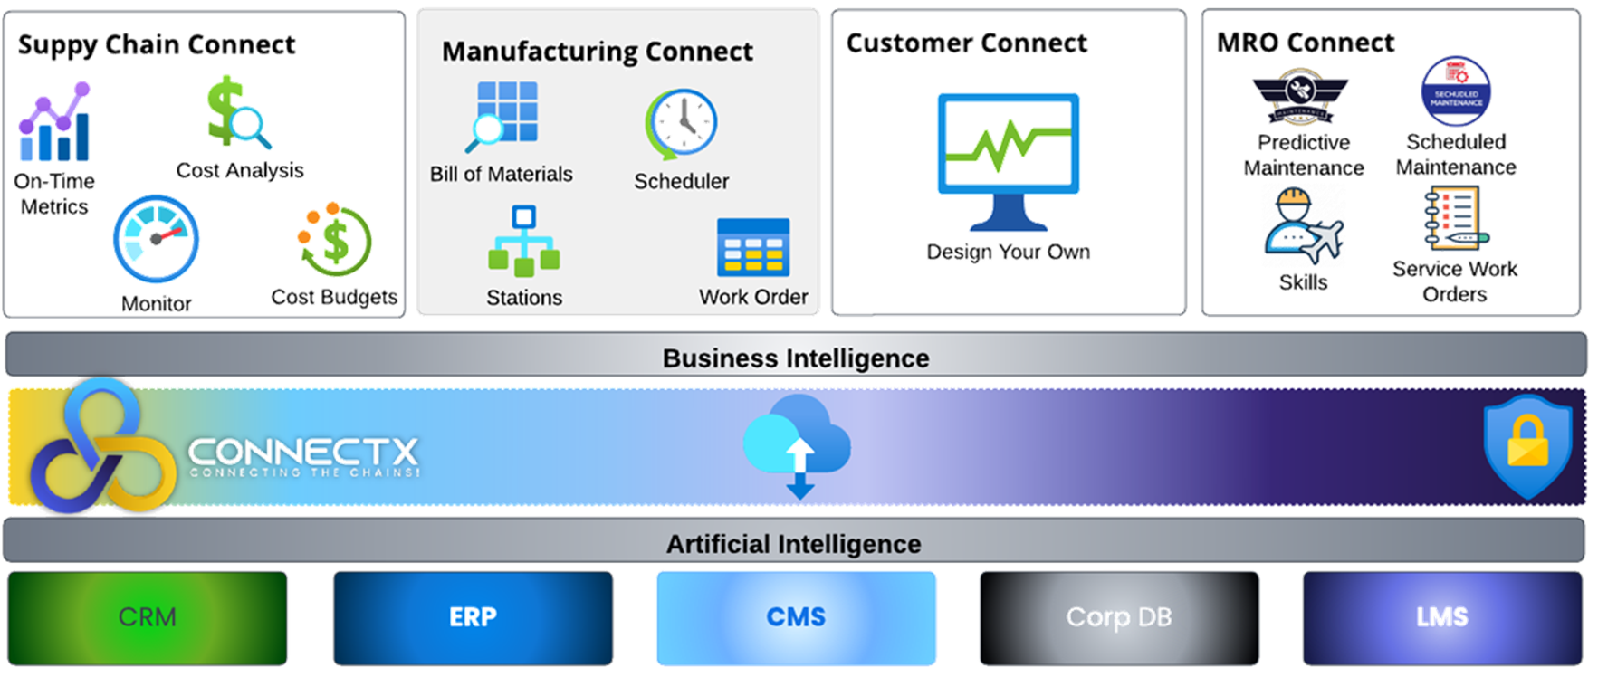  MODULES:  MRO ConnectX  It is amazing how fast and simple it can be to create a FAA8130 from many sources. With just a few clicks, you can bring your ERP sales order, item fulfillment, and repair data together to produce a FAA8130 ready for signature in a couple of minutes.  Supply Chain ConnectX  In the fast-paced world of aviation, where precision and timeliness are paramount, Epiphany’s Supply Chain ConnectX is an essential tool for complex supply chain challenges such as the uncertainties of inflation, fluctuating customer demand, and the pervasive issue of labor shortages. This state-of-the-art management solution will propel your business into a new era of agile operations.  Manufacturing ConnectX  The manufacturing module is in the works and will be ready soon!

Business Benefits and Features
ConnectX Platform
Real-time visibility across your business portfolio
Business Benefits | Features
Obtain a 360-degree view of data from any source.  ConnectX allows you to:  - Integrate with any of the following:  - Quickbooks  - NetSuite  - Salesforce  - Many more to come…  - Pull data from customer pdf specifications into a readable table  - Track information pulled from any source  - Edit information before pushing to system of origin  - Pull and Push Data from PDF Document to Table | - Integrations with multiple systems already developed  - Integration with Financial System  - Dashboard Capability  - Built-in Business Intelligence

